daily: festival, weekday and weekend (Friday sat sun)

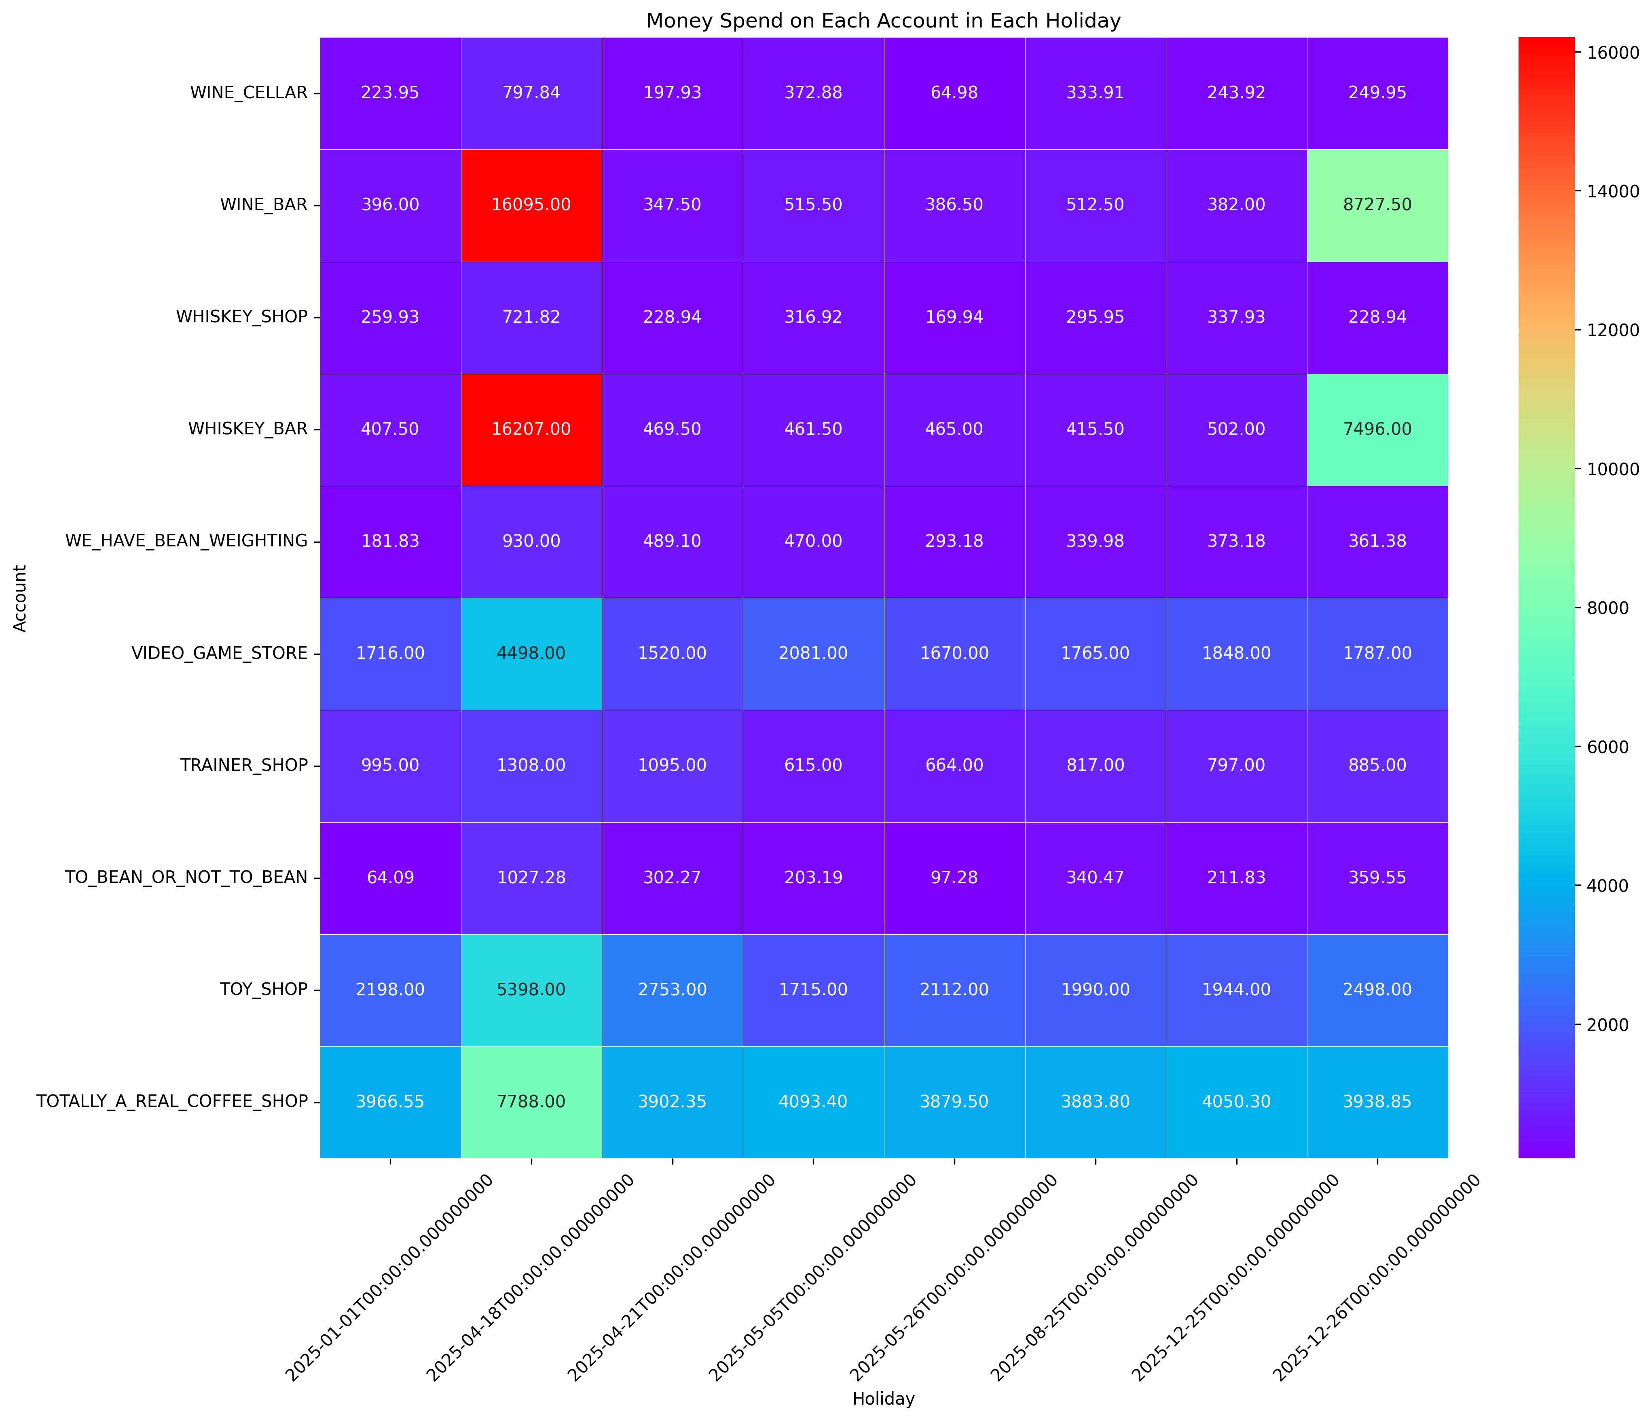

This heatmap shows the top ten businesses in each holiday, people tend to spend money on WINE_BAR and WHISKEY_BAR more than 2 times of other businesses. The trend remains consistent even on Boxing Day, where these alcohol-related venues maintain their dominance in customer spending. This finding suggests that there is a cultural association between celebration and parties with alcoholic beverages.

Clearly, people allocate a portion of their expenditure toward these specific businesses. Recognizing alcohol-related spending throughout the year can make us market suitable strategies for customer preference.

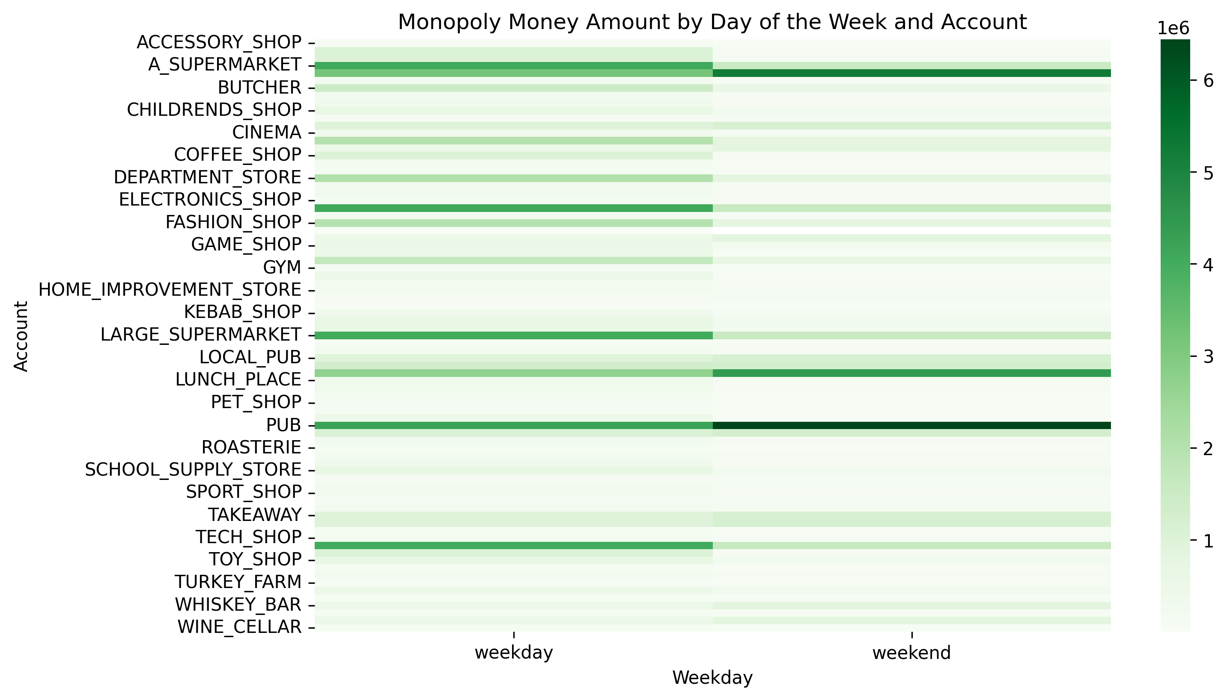In normal day, alcohol-related businesses still gain a lot of money from people in weekend followed by supermarket; however, in weekday people mostly spend money on Supermarket and Electronic.

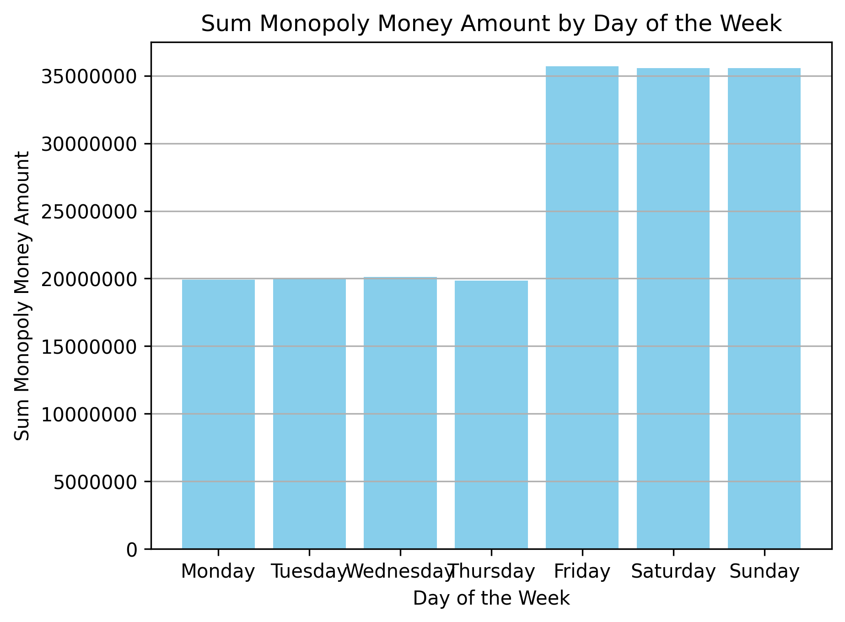

Clearly, most of the business income is on Friday to Sunday, related to pub and bar income because people go to pubs when tomorrow is free. So, it is unsurprised that why people spend money more on Friday to Sunday.

Demi: why use sum? From Monday to Sunday in 2025 is [52, 52, 53, 52, 51, 52, 52]

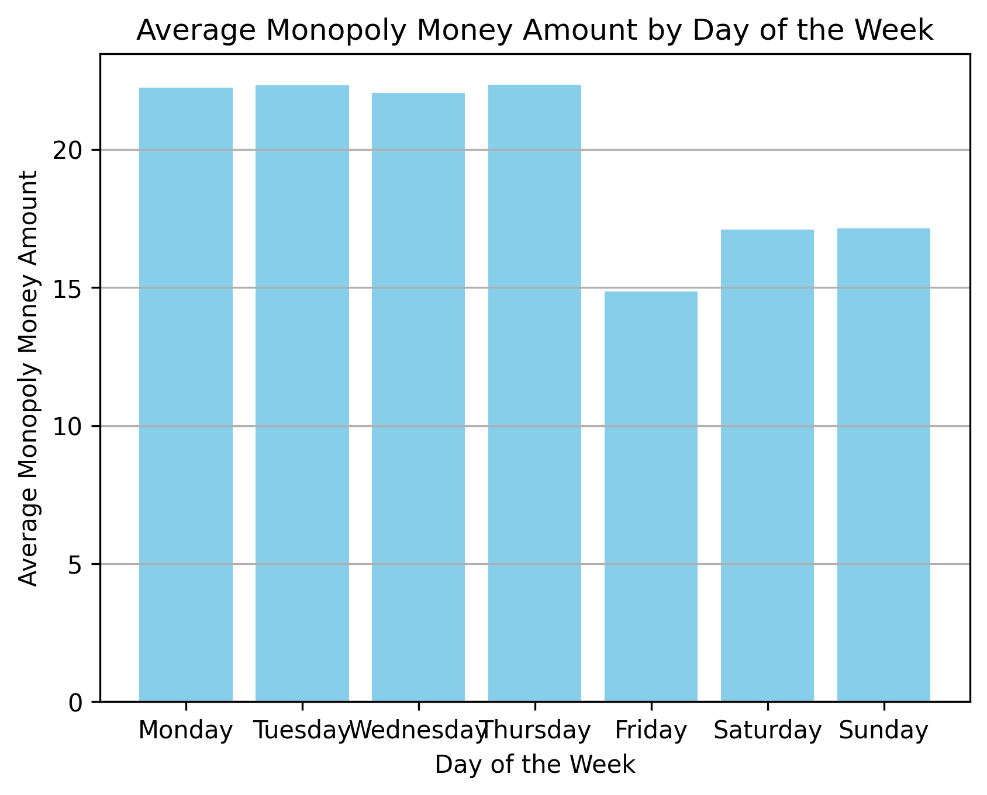

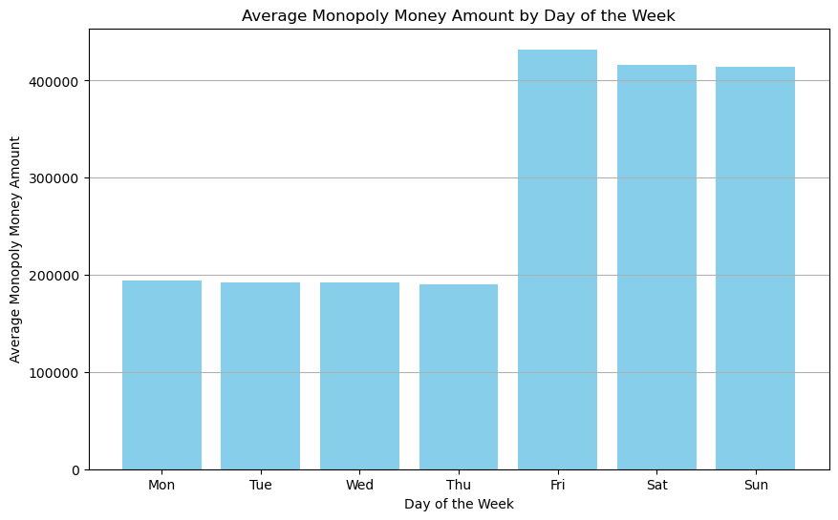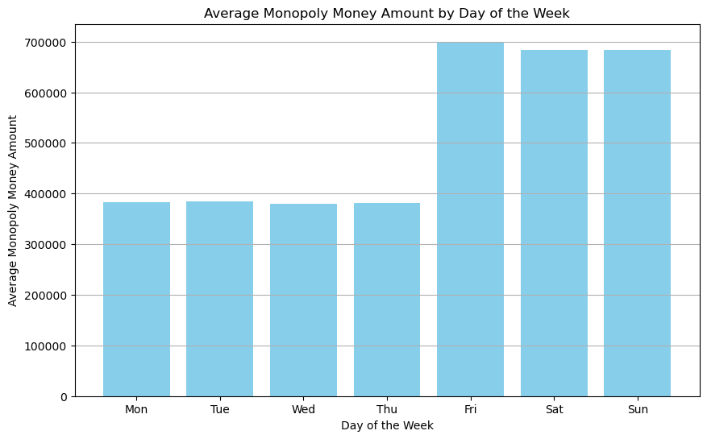

Both the overall transaction volume and the merchant transaction volume exhibit a similar pattern, where the transactions on Friday, Saturday, and Sunday are substantially higher compared to other days, with Friday recording the highest volume of transactions.

Monthly: month-end decrease, decrease and increase in several months, top 10 store

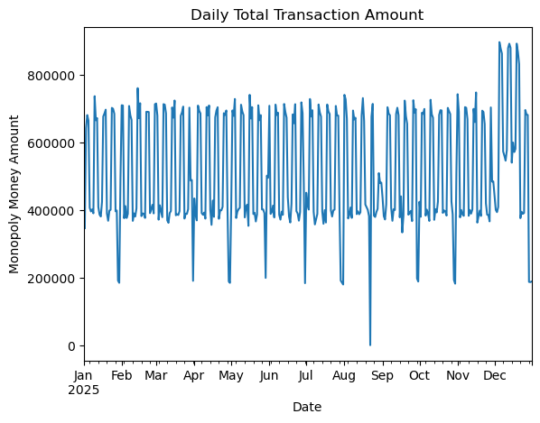Figure 1 & 2 & 3

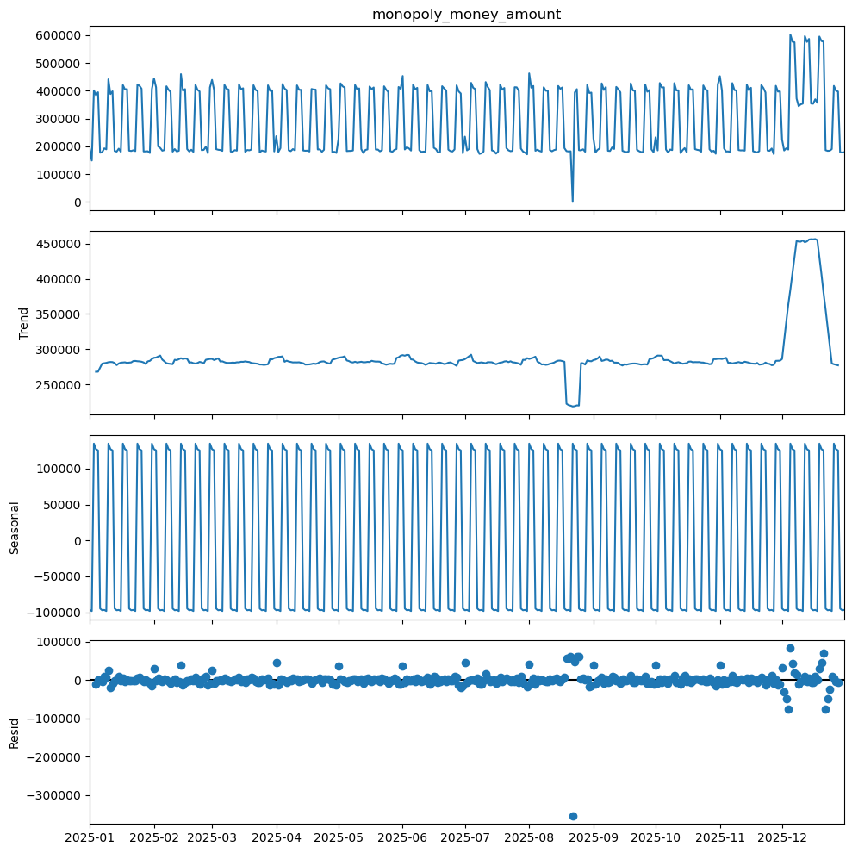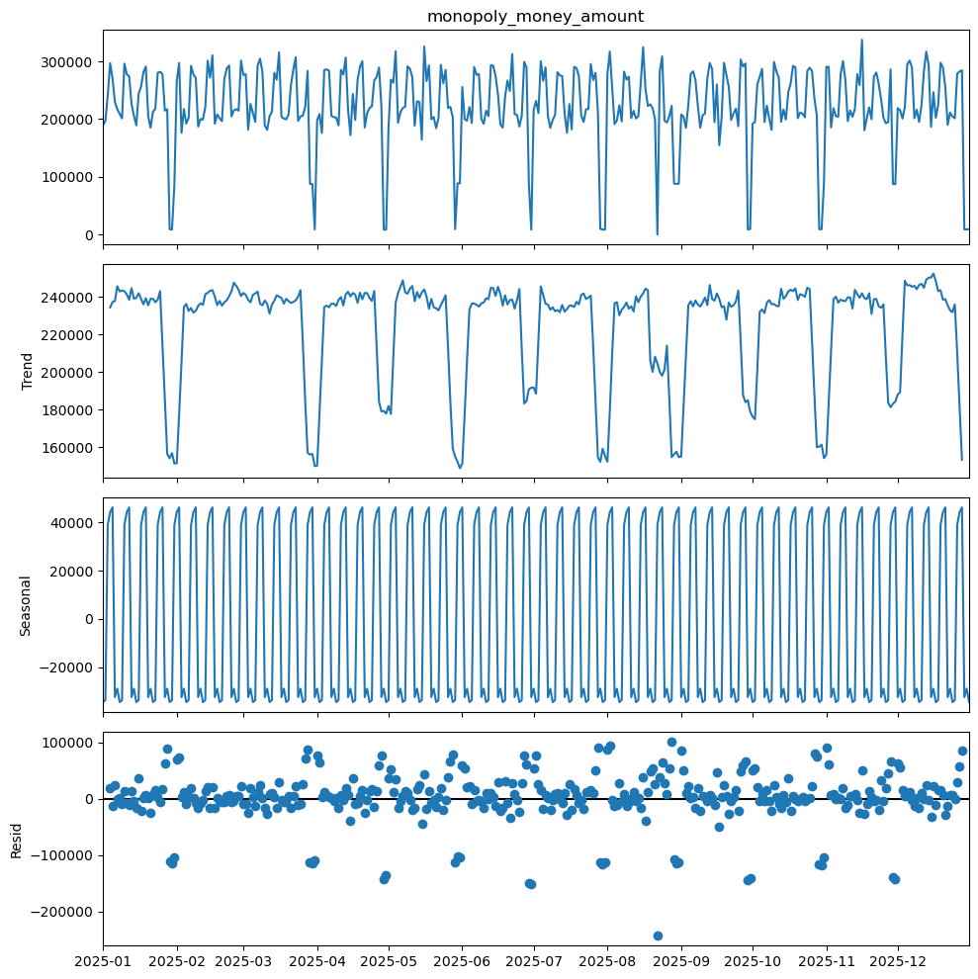

From Figure 1, we observe periodic fluctuations and missing data - August 22nd.

By breaking down the transactions into Figure 3 for merchant transactions and Figure 4 for personal transfers, we find that merchant transactions exhibit weekly fluctuations with a rise in December.   
Conversely, personal transfers demonstrate a downturn at the end of each month.

There are 79 stores for merchant transactions. Among them, the "FLORIST" only makes transactions on February 14th, and the "TURKEY FARM" only in December. The other 77 stores have transactions every month. "STREAMING SERVICE" and "GYM" only transact on the first of each month.

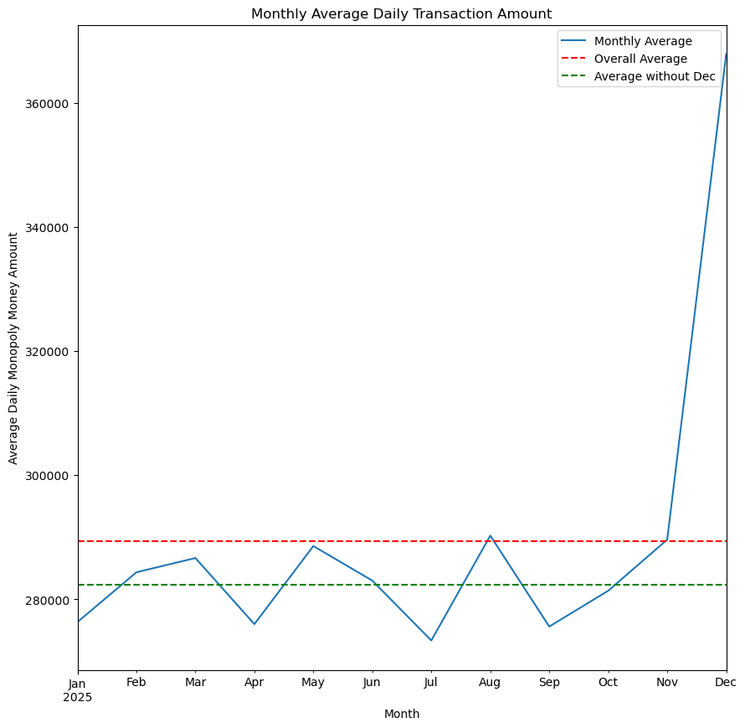Figure 1 & 2 & 3

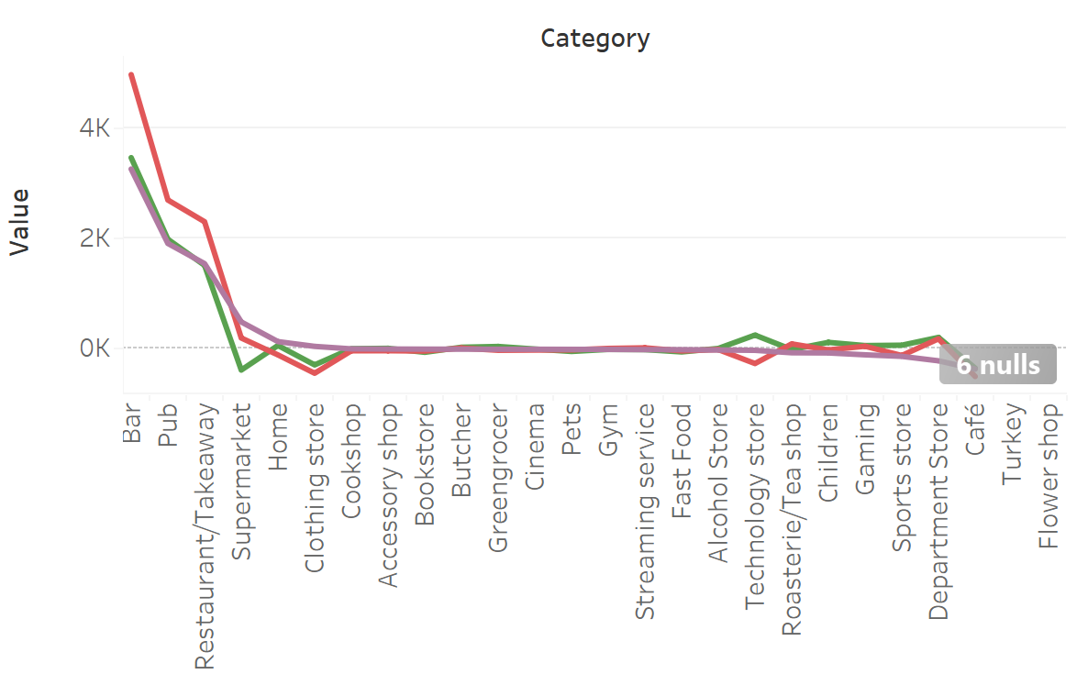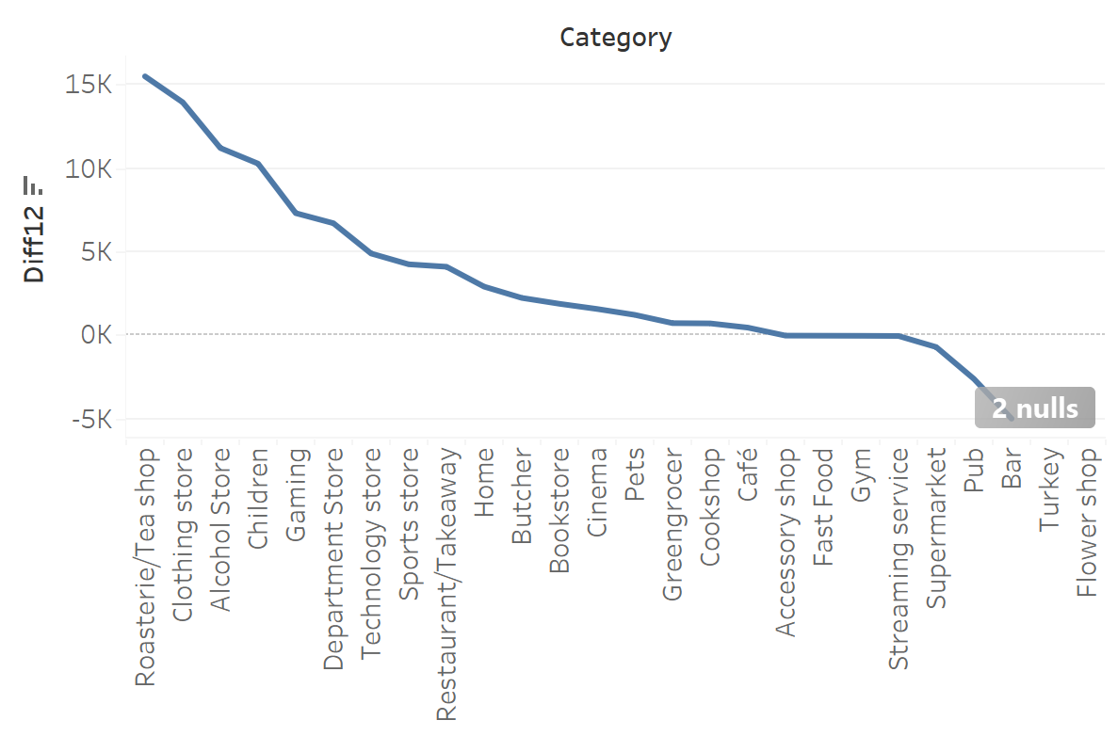

Focusing solely on merchant transactions, Figure 1 illustrates a rise in the average daily transaction amount in December, and a decrease in the same during April, July, and September.

By the merchant categories, we notice from Figure 2 that the decline in these months is primarily driven by three types of merchants: "Bar," "Pub," and "Restaurant/Takeaway." Conversely, as shown in Figure 3, the increase in December is predominantly due to categories such as "Tea Shop," "Clothing Store," "Alcohol Store," and "Children's Store" among others.

